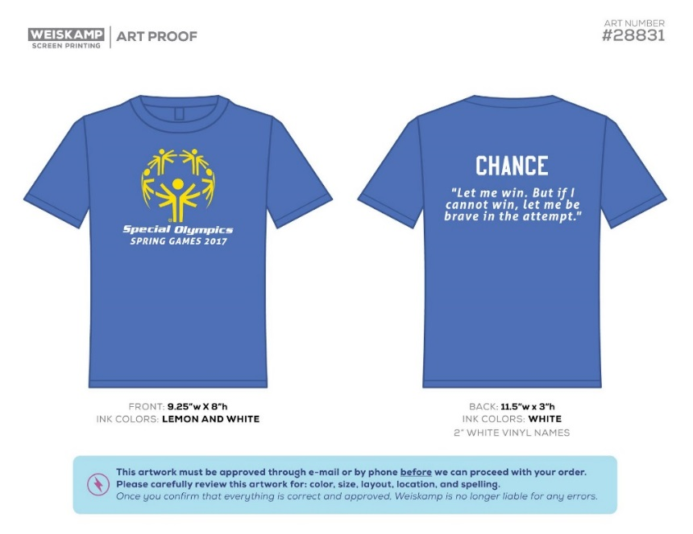

Order Form
Show your support for our student athletes competing in The Special Olympics on April 28th, 2017!

*T-shirts will be grey with yellow and white lettering*
Order information:

Size/quantity Price Each Total

Youth S____ M____ L____ XL____ $12.00 _______

Adult S____ M____ L____ XL____ $15.00 _______
(Additional sizes available upon request, please note below)

Order Total: _________

Name: ______________________________

Phone number: ______________________

Payment Method: Please circle one
(Payment due with order form)

Cash Check (made payable to Villa Grove Schools)

Orders and payments due by Friday, March 3rd, 2017!

T-shirt pick-up will be April 10th, 2017 from 6-7pm in the school cafeteria

